|  |
| --- |
| Circle Language Spec: Commands |

## Creation Behavior Of Calls in a Diagram

The creation behavior of calls was already explained in the article *Creation Behavior Of Calls*. The current article demonstrates the concept in a diagram.

The steps of creation of a call are clarified with diagrams.

Before a command is running, it is in the current state:

- Command is created

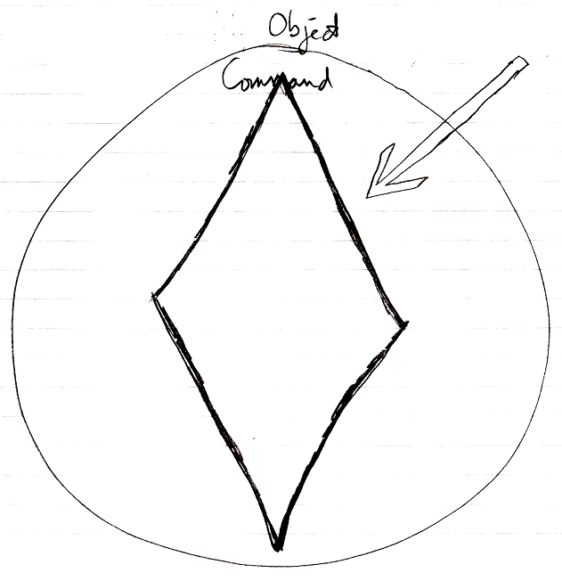

- Parameters / public contents are present

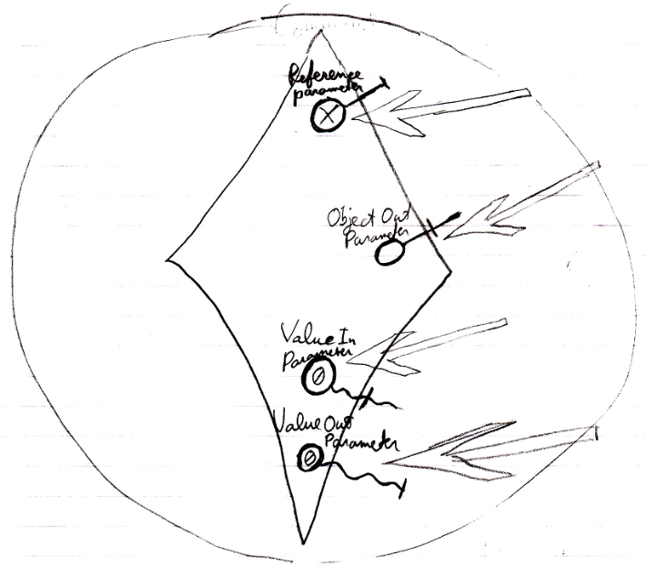

- Private contents are *not* created  
(private objects, clauses and command calls)

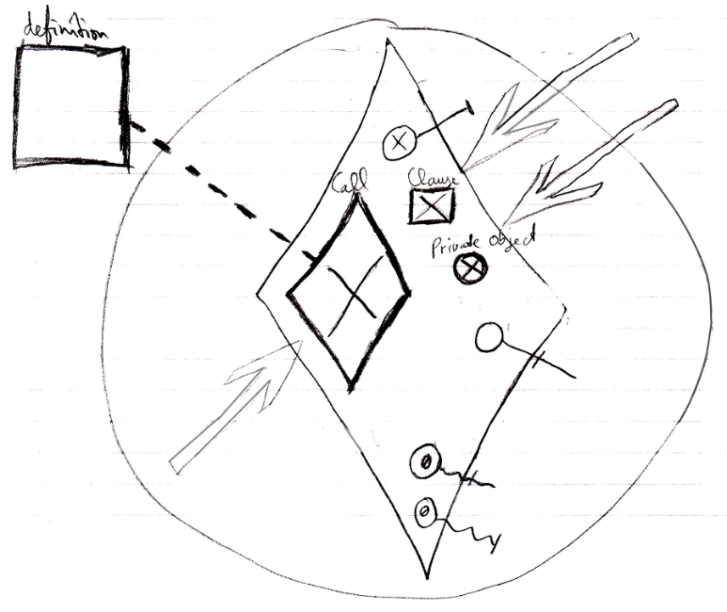

- Reference and Object Out parameters are already assigned

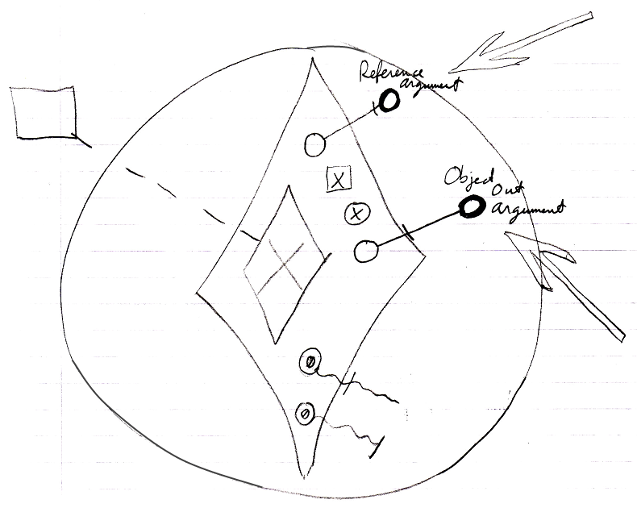

- Value parameter assignments refer to their sources and targets

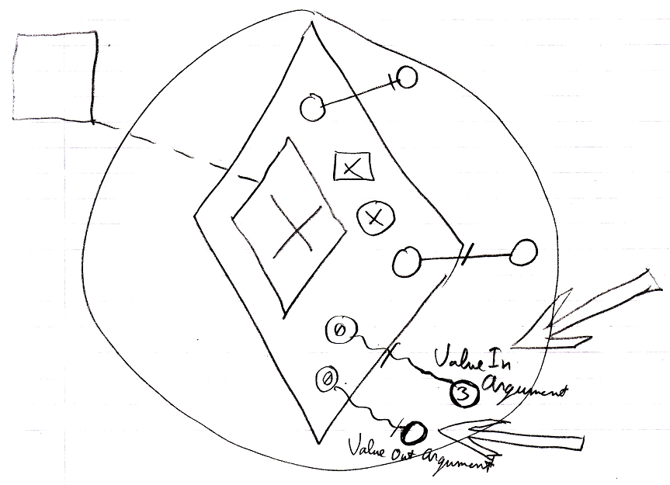

Right before a command executes:

- Value In parameter assignments are executed

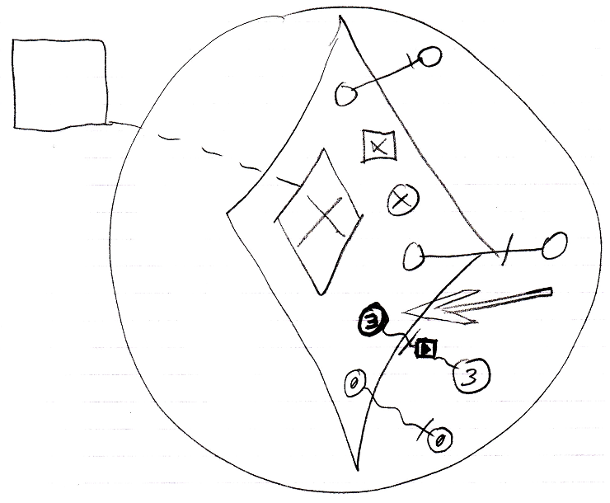

- Private contents are created  
(private objects, clauses and command calls)  
(copied from the command’s definition)  
(The definition of the parent command is not shown in the diagram.)

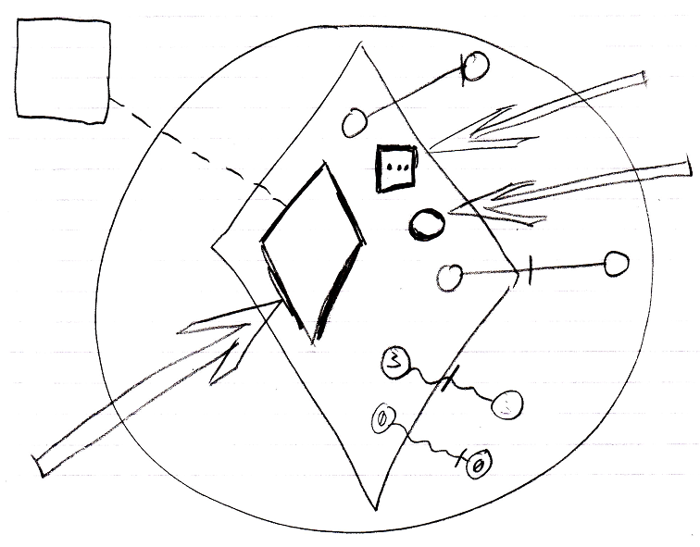

- *Sub*-commands’ parameters / public contents are created  
(copied from the sub-command’s definition)  
(The contents of the definition of the sub-command are not shown in the diagram.)

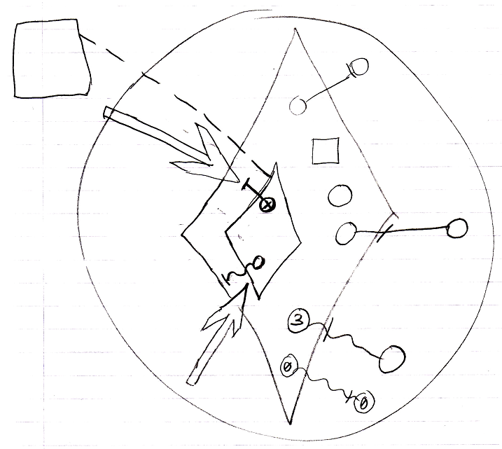

- Mind, that the sub-command’s private contents are not created, which includes its private objects, command calls and clauses.

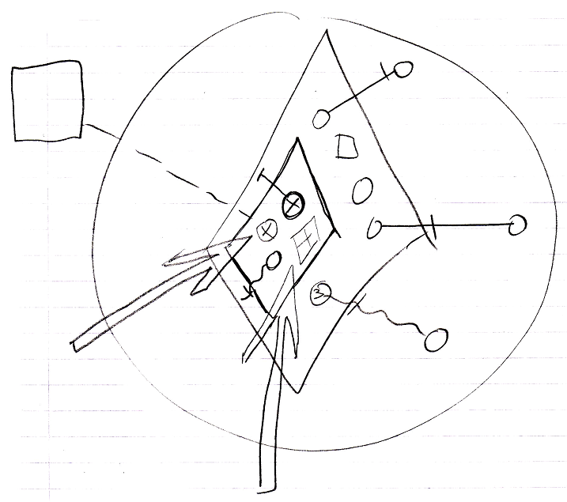

- *Sub*-commands’ Reference and Object Out parameters are assigned  
(targets copied from the parent command’s definition)  
(The definition of the parent command is not shown in the diagram.)

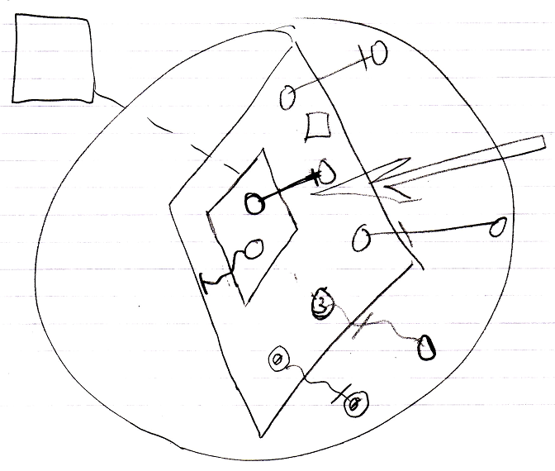

- Sub-commands’ Value parameter assignments refer to their sources and targets  
(copied from the parent command’s definition)

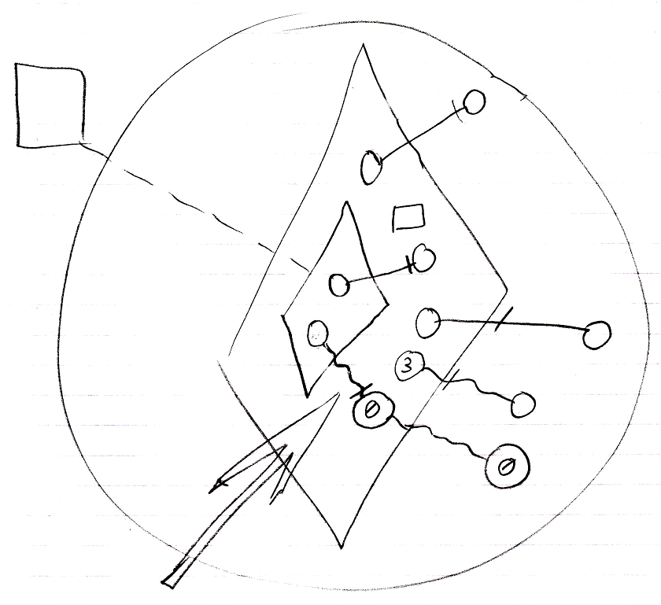

Then the command runs:

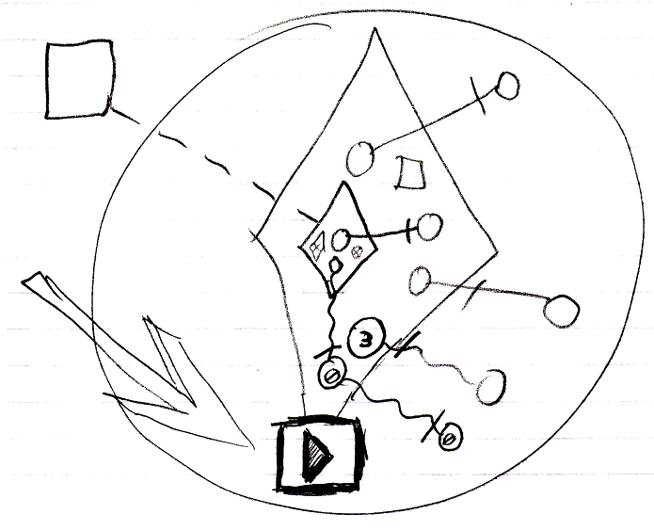

which means it runs all its sub-commands one by one, following the same procedure. The sub-command’s public content needed to be created in order to instantiate the parameter passings, part of the parent command.

After a command has finished:

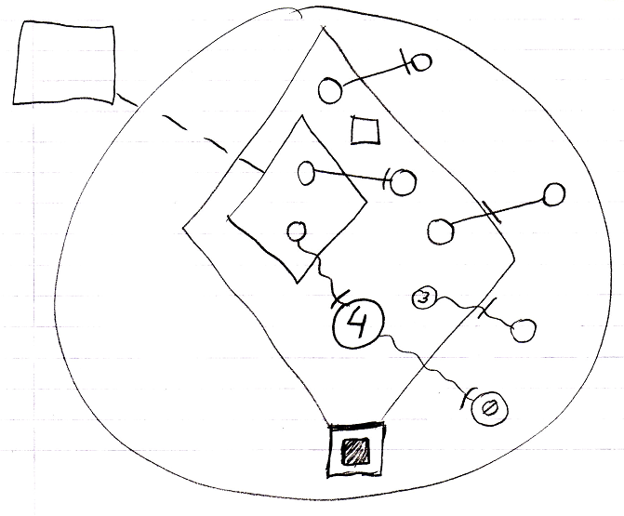

- Value Out parameter assignments are executed

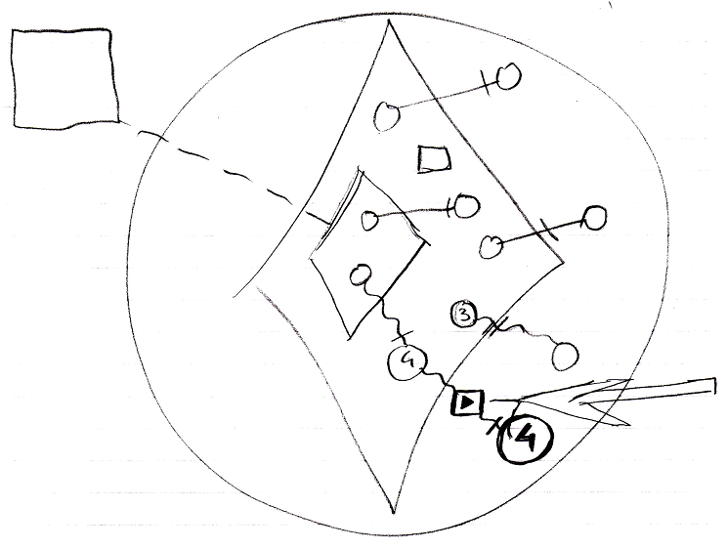

- Private contents are released  
(private objects, clauses and command calls)

